From:
The Reckoning Begins
By David Stockman. Posted On Friday, November 23rd, 2018
The chart monkeys are getting eviscerated. Like a hot knife through butter, the S&P 500 has plunged through the 50-DMA (2800), the 200-DMA (2760) and the so-called 50-week MA maginot line or 350-DMA (2682) with alacrity.
At today's close of 2632, the broad market index is now hanging from a sky-hook---down 6.0% from its first line of defense at the 50-DMA and nearly 2.0% from its last line of defense at the 50-week MA. As shown in the chart below, this is the first time since the February 2016 swoon that the market's maginot line has been pierced .
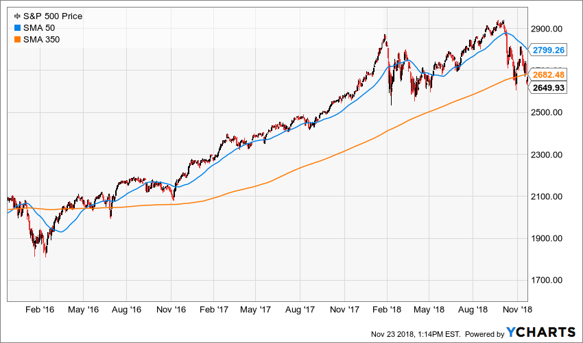
But this is a lot more than a "retest" of a nearly three-year old chart point. Since then global fundamentals have deteriorated badly---and not the least owing to the increasing level of sheer madness emanating from the Oval Office. That is, the Donald's Border Wars, Trade Wars, Fiscal Debauch and a populist war on the Fed.
As to the latter, the Donald has now gone full retard with his "low interest" snake oil. Notwithstanding the fact that the Federal funds rate at 2.13% is still below the 2.3% Y/Y inflation rate, and is therefore negative in real terms as it has been for the past eight years, Trump is now actually tweet-storming in behalf of a rate cut:
"I'd like to see the Fed with a lower interest rate. I think the rate's too high. I think we have much more of a Fed problem than we have a problem with anyone else," Trump said to reporters outside the White House.
That tells you all you need to know. As the Fed belatedly sticks to its guns on monetary policy normalization it is setting up with absolute certainty an unprecedented Oval Office attack on the Eccles Building. And it will shake the casino to its rafters when it fully materializes.
So in the interim, unless the momentum driven day-traders and robo-machines get another excuse soon to push the market indices back above their support lines what happens next is the long-delayed reckoning. That is to say, the return to honest price discovery in a market where the central banks are fast repairing to the sidelines and the chart-monkeys are no longer being greenlighted to buy the dips.
In that environment, we think the first thing to go will be the end stage Trump Bubble, which incepted at 2130 on the S&P 500 on November 7, 2016 and then rocketed, irrationally, to the September 21, 2018 peak at 2940. That amounted to a 38% gain, but there never was a modicum of sanity to it.
That's because the Great Disruptor had no program at all to make MAGA, but did possess a dog's breakfast of prejudices, palliatives and poppycock that were a fair bet to finally sabotage the 10-year fantasy that followed hard upon the Lehman meltdown. After all, what exactly was the casino capitalizing at nosebleed PE multiples on its 38% rip to Peak Trump---other than its own self-terminating momentum?
It certainly wasn't robust earnings growth---notwithstanding Wall Street's risible assertions. In fact, LTM earnings for Q3 2018 are now almost complete, and they amounted to $130 per share on the S&P 500. But about $6 of that was the one-time impact of the 21% corporate rate, not organic growth; and, in any case, it will anniversary out of the numbers come Q1 2019.
So if you compare $124 per share of apples-to-apples earnings with the $106 share level reached four years ago in September 2014, the annualized growth rate amounts to a piddling 4.0%. And if you reach back to the $85 per share posted at the pre-crisis peak 11 years ago for the June 2007 LTM period, the rate of gain is just 3.5% per annum.
And that's all she wrote for the present business cycle, which is now nearing the end of month #113. That makes it the second longest expansion in history and one which stands just shy of the 120 month record achieved during the far more propitious conditions of the 1990s tech boom.
So even if this expansion has a few more months, quarters or even several years to run, there is no conceivable acceleration of profit growth that could lift the peak-to-peak earnings growth rate to even 5.0%.
Yet even at today's plunging levels, PE multiples stand at 21X, 22X and 45X for the S&P 500, NASDAQ 100 and Russell 2000, respectively. How do those cap rates possibly compute at four to eight times the cyclically adjusted growth rate of profitability?
Moreover, that's not even the half of it because the above figures reflect the badly falsified per share earnings that were posted by the C-suites during the final years of Bubble Finance. That is to say, "earnings" that were generated by massive debt-fueled stock buybacks that were the step-child of falsified debt costs.
By contrast, here is the official data for total nonfinancial business profits published by the Commerce Department. This data has the advantage of being based on corporate tax returns filed with the IRS by companies that have no incentive whatsoever to hype their bottom line and thereby qualify themselves for higher tribute payments to Uncle Sam.
These figures also eliminate the illusion caused by borrowing money to liquidate equity shares; and they also control for an apples-to-apples tax rate and eliminate the Fed-swollen profits of the financial sector. What the chart shows, of course, is that the $1.253 trillion annualized rate of profits reported for the most recent period (Q2 2018) is a tad smaller than the figure from 12 years ago in Q3 of 2006!
That's right. Honest injun corporate profits have actually been declining since the interim peak of $1.439 trillion in Q3 2014 and are now struggling to main the level reached at the top of the phony Greenspan housing boom.
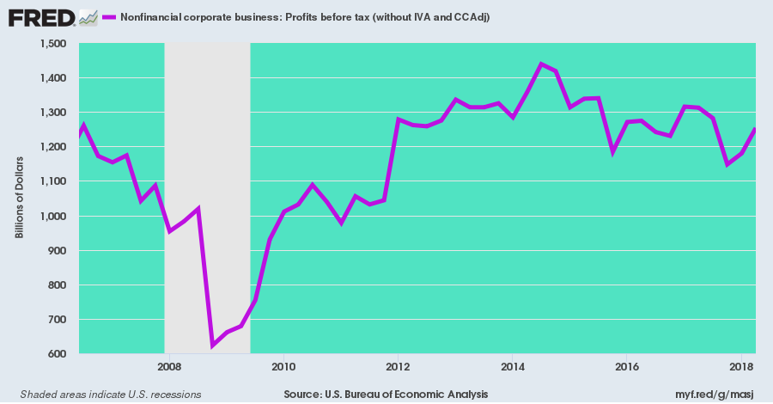
Needless to say, it is now only a matter of time before the financial engineering component of S&P 500 reported earnings is wrung out of SEC filings. That's because the drastic build-up of corporate debt since the pre-crisis peak will soon be extracting a huge penalty from per share profits.
To wit, compared to the after-tax interest cost of $19 per share reported for 2017, a rise of the benchmark 10-year Treasury rate to even 3.7% will cause interest charges by the S&P 500 companies to soar to $50 per share, thereby eliminating most of the hockey stick earnings growth currently being peddled by the Wall Street sell-side.
Indeed, corporate debt has virtually gone parabolic since the Q4 2007 pre-crisis peak, and the interest thereupon will needs be paid---even when the impending next in line recession drives operating profits down by 20-40%, as is typically the case during recessions.
Stated differently, the casino is capitalizing a business cycle that never ends, while ignoring an explosion of interest carry costs that are already baked into the cake. Accordingly, we'd bet that S&P 500 profits will revisit $75 per share long before they reach Wall Street's current two-year forward estimates of $175 per share, if ever.
In this context, just consider the debt piece. The $9.4 trillion level reported for Q2 2018 it was actually up by a full 50% from the pre-recession level.
It was only the Fed's drastic and reckless suppression of interest rates during the interim period that enabled companies to temporarily hide the cost of an unprecedented corporate borrowing spree; and one that was devoted almost entirely to pumping cash back into Wall Street to fund buybacks, dividends and M&A deals, not productive investment in real plant, equipment and technology and capacity for future growth.
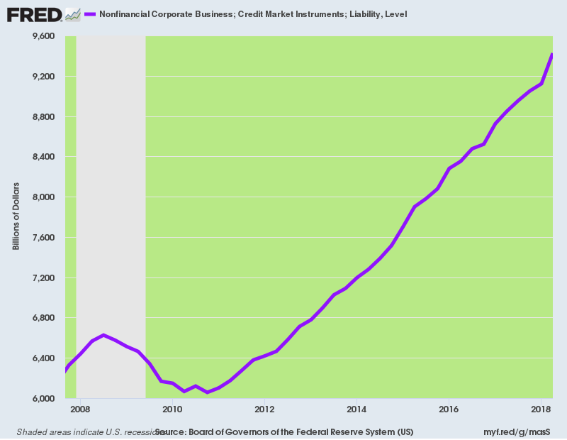
Next to the Donald's impending attack on the Fed even as Uncle Sam floods the bond pits with upwards of $1.2 trillion of new borrowing during the fiscal year underway, there remains his full throated attack on China. Yet if the central banks created the current global bubble by expanding their balance sheets by $21 trillion during the past 14 years, the Red Ponzi is its ultimate Achilles Heel.
On the margin, China's $525 billion of annual exports to the US are what keeps this $40 trillion debt-fueled freak of economic history from imploding. And even if there are some initial signs of concordance from the Xi/Trump meeting at the G-20 next week, we think they won't last even a day.
That's because America's giant $375 billion trade deficit with China was largely made in the Eccles Building a few blocks from the White House, not by the machinations of China's politburo 12,000 miles away. Accordingly, there is no real basis for a Trumpian style deal, and the virtually certain probability that tariffs of 10% to 25% will be imposed on all imports from China next year.
As we have frequently reminded, the Donald's China tariffs will hit the US economy with an inflationary gale force because upwards of $1.7 trillion of domestic goods consumption (or 40% of the total) is driven by the China Price on the margin. Accordingly, both domestic and foreign competitors will be afforded a giant price umbrella under which they can both substantially raise prices and gain market share, too.
In a word, the Donald's 2019 Trade War will be the final blow to the era of Bubble Finance--forcing the Fed into an accelerated normalization round, even as it finally sends the Red Ponzi into a catastrophic tailspin.
As to the latter, we got into the pending China conflagration hot and heavy with our host today during an appearance on Fox Business.
https://www.youtube.com/watch?v=hqS0IgEcN6Y&feature=youtu.be
In this context, the astute observations of Wolf Richter about the on-going meltdown of the FANGMAN [Biggest tech Stocks] stocks speak for themselves. The combined market cap is now down $905 billion since the end of August, and right on schedule mark the crashing of the momo stocks that always leads the way down in a bear market.
As we have noted elsewhere, at the 2000 peak the equivalent of today's FANGMAN was the 12 Big Cap High Flyers of the era including Intel, Microsoft, Cisco, Dell, GE, Lucent and six others. Much like the chart below, these 12 saw their combined market cap soar from $600 billion in December 1996 at the time of Greenspan's infamous "irrational exuberance" warning to $3.8 trillion at the top in April 2000.
Moreover, these weren't the no revenue/no profits dotcoms being valued on the basis of eyeballs, as is so frequently dismissed by today's talking heads. To the contrary, the 12 High Flyers had tens of billions of sales and billions of profits, each.
Nevertheless, when the market broke fully $2.7 trillion of market cap vanished.
As we will address next week, the bottled air now rushing out of the FANGMAN stocks bears an uncanny resemblance to the implosion which occurred at the heart of the tech bubble in the year 2000. Like today, the 12 High Flyers were for the most part strong companies that had become drastically over-valued at the bubble peak.
In the current case, the same kind of drastic re-set of valuations is now well underway as per Wolf Richter's recent review:
Despite the sell-off, the FANGMAN as a whole are still green for the year, and are back where they’d first been on January 11. So, from that perspective, this $905 billion that disappeared isn’t any kind of big deal unless it’s your money that disappeared along with it: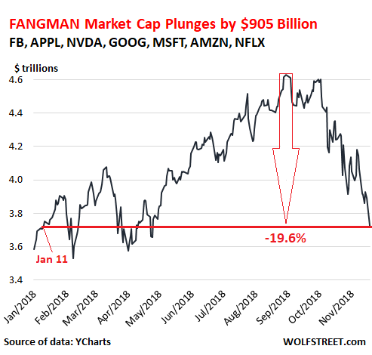
Let’s start by blaming Apple [AAPL] due to its number 1 mega-cap status. Its shares dropped nearly 4% today and are down 20.4% from their peak at the beginning of October. Once upon a time, the company was worth $1.12 trillion. It ended the day at $882 billion. $238 billion gone in ca. eight weeks.
Not a day goes by when we don’t hear from an Apple supplier blaming an unnamed huge customer that can only be Apple for having to slash their revenue forecasts – apparently because three iPhone models are not selling very well.
Apple’s principle that it can always make up for falling sales of devices by raising prices even further on the fewer devices it sells can only succeed for so long. At some point, consumers switch to something else or just refuse to “upgrade” at an ever faster rate, as Apple has to raise prices at an ever faster rate…. You know where this is going.
Now I’m waiting for the day when Apple has to cut prices to get device sales going again. The fireworks should be pretty. The thing is Apple cannot be the only company in the universe that is able to forever increase its revenues by raising prices even as its unit sales are falling.
If Apple shares keep dropping like this, and Microsoft shares keep falling at their own pace, Apple may soon be less valuable than Microsoft. That would be too much to bear.

Microsoft [MSFT], the second most valuable company in the S&P 500, dropped 3.4% today to $104.62 and is down 10% from its peak at the beginning of October.
Facebook [FB] dropped 5.7% today, to $131.55, a new 52-week low. Shares are down 40% from their peak in July. And $249 billion in market cap have gone up in smoke.
Facebook, its CEO Mark Zuckerberg, and its COO Sheryl Sandberg had been media darlings for years, giving empowering and inspiring speeches, despite all the scandals over the way Facebook handles and monetizes the data it collects on everyone. But that goodwill has blown up, and now there’s nothing but revelations about the inner gears of its greasy machinery. I have no idea why anyone is still on Facebook or is still using its other apps, and other people are coming to the same conclusion.
On my list of things to watch in terms of real estate: Facebook, which had no presence in San Francisco until mid-2017, signed San Francisco’s largest-ever office lease in May – 755,900 square feet in the 43-story Park Tower – about two months before its stock began to collapse. Shares are now down 40%. My gut feeling is that once shares are down 60% or so, the music will change, and instead of filling this tower with its employees, it’ll embark on a cost-cutting drive, and this office space will appear on the sublease market. This is how real estate in San Francisco falls apart when stocks fall apart.
Amazon [AMZN] dropped 5.1% today to $1,512.29 and is down 26% from the peak on September 5, when shares almost kissed for the briefest moment $1 trillion. Up by escalator, down by elevator. $254 billion have gone up in smoke. No one on Wall Street griped when market cap jumped by $254 billion in 12 months for no reason, but now the wailing and gnashing of teeth is deafening.
Alphabet [GOOG] dropped 3.9% today to $1,020.00 and is down 20% from the peak in July.
NVIDIA [NVDA] has been in the plunge business recently. This was one of the most over-hyped stocks driven even higher by the crypto-scam that is now bleeding out (it sold chips to crypto-miners). On Friday, the company reported earnings, and shares plunged another 19%. Today shares plunged another 12%. Now at $144.70, shares are down 50.5% since the beginning of October and are back where they’d been in June 2017. Dip buyers were taken out the back and shot every time.
Netflix [NFLX] dropped 5.5% today to $270.6 and has plunged 35% from its high in early July. But it is still green for the year and has a very long way to go.
In other words, it gets costly in a hurry when the entire market depends on a handful of mega-caps that have been over-hyper for years.

